HISTORY of REVISION
Rev.  No. | Effective Date | Revised Page (s) | Description | Prepared by | Checked  by | Noted  by | Approved by
01 |  |  | New | GJHO | DJN/HM | ON | FM
Prepared by | Checked by | Noted by | Approved by
Grezil Joie H. Ortega | Dexter J. Navales Hiroyuki Mitsui | Osamu Nakai | Fumio Mizuno
Date: | Date: | Date: | Date:
IMPORTANT:
THIS COVER SHEET FORM IS PART OF THE FOLLOWING DOC SHEETS AND IS NOT TO BE DISCARDED UNLESS SUPERCEDE BY A REVISED ISSUE. UNAUTHORIZED REPRODUCTION IS STRICTLY PROHIBITED.

CONTENTS
I. General Description 3
II. Important Monitoring Items 4
1. Controllers’ Description 4
2. Instruments’ Description 4
3. Motors 4
4. Actuated Valves 4
5. Switches 4
1) ESD Maintenance Bypass Switches 4
2) H2S (SIS) Maintenance Bypass Switches 6
III. Interlocks/Controls 9
IV. Control Sequences 9
V. Alarms 9
VI. DCS Emergency Shutdown 9
VII. Trend Graphs Grouping 9
Annex 1: ESD MAINTENANCE BYPASS SWITCH DCS Graphics 10
Annex 2: H2S MAINTENANCE BYPASS SWITCH DCS Graphics 11

General Description

ESD and SIS are very important safety system of THPAL plant that provides emergency shutdown of HPAL 102/202, MS Plant and H2S Plant when hazardous condition in the process area is occurring. The ESD and SIS are triggered by process alarms (instrument/equipment alarms), manual pushbutton or Electric Power Failure. Refer to TNH-200-102 Emergency Shutdown (ESD) Manual for detailed discussion of ESD and SIS.

Each process alarm linked to ESD and SIS has designated maintenance bypass switch. When these bypass switches are activated, the signal from the process alarms are cut off thus preventing activation of ESD or SIS by process alarm conditions. However, ESD and SIS manual pushbuttons and electric power failure signals are still active and ESD or SIS can still be activated when any of these two signals are triggered. Refer to Figure 1-1 for block diagram of the maintenance bypass function.

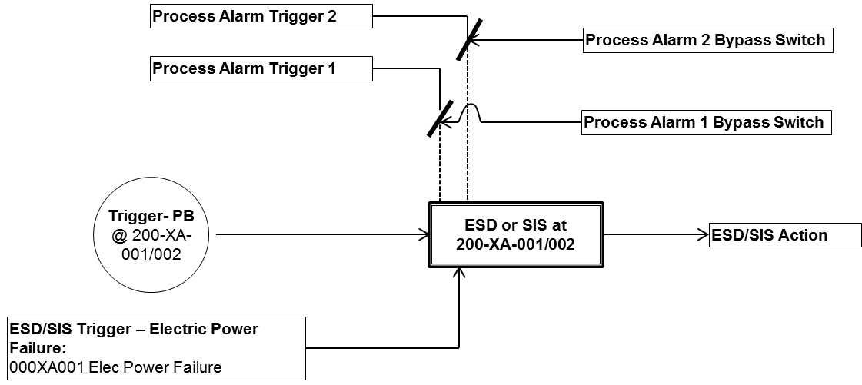

Figure 1-1: Maintenance Bypass Switch Block Diagram

The ESD Maintenance Bypass Switch Graphics provides operator access on the bypass switches of HPAL 102/202 and MS Plant ESD process alarms (refer to Annex 1). On the other hand, the H2S Maintenance Bypass Switch Graphics provides bypass switches for H2S Plant SIS process alarms (refer to Annex 2). Each bypass switch button in the DCS graphics has the name of the equipment and description of the instrument/process alarm.

During normal operation, these bypass switches must be deactivated in order to ensure safe operation of the Plant. Deactivated bypass switch buttons are colored light yellow. . In case of maintenance servicing or instrument’s testing and calibration the specific button must be clicked by the DCS operator in order to activate the maintenance bypass switch and prevent activation ESD or SIS. Activated bypass switch are colored light brown in order to distinguish it from other switches.

Important Monitoring Items

Controllers’ Description
None

Instruments’ Description

None

Motors

None

Actuated Valves

None

Switches

ESD Maintenance Bypass Switches

Table 2-1: ESD Maintenance Bypass Switches
UZ Description | Process Alarm | Bypass Switch
102/202-UZ-600 – Autoclave Shutdown | 102/202AC01 Level HH  – 102/202-LA-028 | 102/202LS028BP
102/202-UZ-600 – Autoclave Shutdown | 102/202HX03 Press HH  – 102/202-PA-006 | 102/202PS006BP
102/202-UZ-600 – Autoclave Shutdown | 102/202AC01 Press HH  – 102/202-PA-010 | 102/202PS010BP
102/202-UZ-620 – Steam Shutdown | 102/202VE04 Level HH  – 102/202-LA-036 | 102/202LS036BP
102/202-UZ-620 – Steam Shutdown | HP Steam Header Press HH  – 102/202-PA-009 | 102/202PS009BP
102/202-UZ-660 – Acid Shutdown | 102/202AC01 Comp.1A Acid Flow LL  – 102/202-FA-007 | 102/202FS007BP
102/202-UZ-660 – Acid Shutdown | 102/202AC01 Comp.1B Acid Flow LL  – 102/202-FA-039 | 102/202FS039BP
102/202-UZ-660 – Acid Shutdown | 102/202AC01 Comp.1A Acid Press LL  – 102/202-PA-023 | 102/202PS023BP
102/202-UZ-660 – Acid Shutdown | 102/202AC01 Comp.1A Acid Press LL  – 102/202-PA-037 | 102/202PS037BP
102/202-UZ-660 – Acid Shutdown | 102/202AG03A Stop  – 102/202XA015 | 102/202XS015BP
102/202-UZ-660 – Acid Shutdown | 102/202AG03B Stop  – 102/202XA016 | 102/202XS016BP
102/202-UZ-660 – Acid Shutdown | 102/202AC01 Comp.7 Level LL  – 102/202-LA-029 | 102/202LS029BP
102/202-UZ-660 – Acid Shutdown | 102/202AC01 Comp.7 Level LL  – 102/202-LA-029 | 102/202LS029BP
102/202-UZ-660 – Acid Shutdown | 416TK01 Level LL  – 416-LA-001 | 416LS001BP
102/202-UZ-660 – Acid Shutdown | 416TK02 Level LL  – 416-LA-002 | 416LS002BP
102/202-UZ-660 – Acid Shutdown | 416TK03 Level LL  – 416-LA-003 | 416LS003BP

UZ Description | Process Alarm | Bypass Switch
102/202-UZ-680 – HP Air Shutdown | 102/202AC01 HP Air Header Pressure HH  - 102/202PA033A | 102/202PS033ABP
102/202-UZ-680 – HP Air Shutdown | 102/202AC01 HP Air Header LL Pressure  - 102/202PA033B | 102/202PS033BBP
102/202-UZ-680 – HP Air Shutdown | Autoclave Shutdown Logic  - 102/202-UZ-600
102/202-UZ-680 – HP Air Shutdown | HP Air Shutdown Push Button at 200-XA-001  - 102/202HS629
102/202-UZ-680 – HP Air Shutdown | Electric Power Failure from PSP  - 000XA001
106-UZ-800 – MS Plant Shutdown | 106VE02 Press HH  – 106-PA-003 | 106PS003BP
106-UZ-800 – MS Plant Shutdown | 106VE02 Level HH  – 106-LA-004 | 106LS004BP
106-UZ-800 – MS Plant Shutdown | 106VE01 Press HH  – 106-PA-002 | 106PS002BP
106-UZ-800 – MS Plant Shutdown | 106VE01 Level HH  – 106-LA-003 | 106LS003BP
106-UZ-800 – MS Plant Shutdown | 106VE03 Press HH  – 106-PA-004 | 106PS004BP
106-UZ-800 – MS Plant Shutdown | 106VE03 Level HH  – 106-LA-005 | 106LS005BP
106-UZ-800 – MS Plant Shutdown | 106VE04 Press HH  – 106-PA-005 | 106PS005BP
106-UZ-800 – MS Plant Shutdown | 106VE04 Level HH  – 106-LA-006 | 106LS006BP
106-UZ-800 – MS Plant Shutdown | 106CP01AB Press HH  – 106-PA-009 | 106PS009BP
106-UZ-810 – H2S Vent Scrubber (106SR02) Shutdown | 106SR02 Level LL  – 106-LA-501 | 106LS501BP
106-UZ-810 – H2S Vent Scrubber (106SR02) Shutdown | 106SR02 O2 HH  – 106-AA-002 | 106AS002BP
106-UZ-810 – H2S Vent Scrubber (106SR02) Shutdown | 106SR02 Press HH  – 106-PA-018 | 106PS018BP
106-UZ-810 – H2S Vent Scrubber (106SR02) Shutdown | 106FN01A Stop  – 106-XA-054 | 106XS054BP
106-UZ-810 – H2S Vent Scrubber (106SR02) Shutdown | 106FN01B Stop  – 106-XA-055 | 106XS055BP
106-UZ-810 – H2S Vent Scrubber (106SR02) Shutdown | 106SR02 H2S HH  – 106-AA-005A | 106AS005ABP
106-UZ-810 – H2S Vent Scrubber (106SR02) Shutdown | 106SR02 H2S HH  – 106-AA-005B | 106AS005BBP
106-UZ-810 – H2S Vent Scrubber (106SR02) Shutdown | 106PU41A Stop  – 106-XA-050 | 106XS050BP
106-UZ-810 – H2S Vent Scrubber (106SR02) Shutdown | 106PU41B Stop  – 106-XA-051 | 106XS051BP
106-UZ-810 – H2S Vent Scrubber (106SR02) Shutdown | 106SR00 Level LL  – 106-LA-510 | 106LS510BP
106-UZ-810 – H2S Vent Scrubber (106SR02) Shutdown | 106PU00A Stop  – 106-XA-500 | 106XS500BP
106-UZ-810 – H2S Vent Scrubber (106SR02) Shutdown | 106PU00B Stop  – 106-XA-300 | 106XS300BP

UZ Description | Process Alarm | Bypass Switch
106-UZ-820 – Scrubber (106SR03) Shutdown | 106SR03 Level LL  – 106-LT-601 | 106LT601BP
106-UZ-820 – Scrubber (106SR03) Shutdown | 106FN02A Stop  – 106-XA-056 | 106XS056BP
106-UZ-820 – Scrubber (106SR03) Shutdown | 106FN02B Stop  – 106-XA-057 | 106XS057BP
106-UZ-820 – Scrubber (106SR03) Shutdown | 106PU51A Stop  – 106-XA-058 | 106XS058BP
106-UZ-820 – Scrubber (106SR03) Shutdown | 106PU41B Stop  – 106-XA-059 | 106XS059BP
106-UZ-820 – Scrubber (106SR03) Shutdown | 106SR03 H2S HH  – 106-AA-013A | 106AS013ABP
106-UZ-820 – Scrubber (106SR03) Shutdown | 106SR03 H2S HH  – 106-AA-013B | 106AS013BBP
106-UZ-800 / 106-UZ-810 / 106-UZ-820 Common | Nitrogen Press LL  – 525-PA-001 | 525PS001BP
106-UZ-800 / 106-UZ-810 / 106-UZ-820 Common | Instrument Air Press LL  – 521-PA-002 | 521PS002BP

H2S (SIS) Maintenance Bypass Switches

Table 2-2: H2S (SIS) Maintenance Bypass Switches
SIS Description | Process Alarm | Bypass Switch
109SIF026 – Process Gas Scrubber (109SR01) High High Pressure | 109SR01 Diff Press HH  – 109-PDA-057 | 109PDT057BP
 | 109SR01 Inlet Press HH  – 109-PA-110 | 1099PT110BP
109-UZ-450 – H2S Conc High High on Emergency Gas Scrubber (109SR02) Discharge | 109SR02 H2S Content HH  – 109-AA-085A | 109AT085ABP
 | 109SR02 H2S Content HH  – 109-AA-085B | 109AT085BBP
109SIF059 - H2S Conc High High on Emergency Gas Scrubber (109SR02) Discharge | 109SR02 H2S Content HH  – 109-AA-083A | 109AT083ABP
 | 109SR02 H2S Content HH  – 109-AA-083B | 109AT083BBP
 | 109SR02 H2S Content HH  – 109-AA-083C | 109AT083CBP
109SIF001 – Emergency Gas Scrubber (109SR02) Unavailable | 109SR02 Upper Flow LL  – 109-FA-076A | 109FT076ABP
109SIF001 – Emergency Gas Scrubber (109SR02) Unavailable | 109SR02 Lower Flow LL  – 109-FA-076B | 109FT076BBP
109SIF001 – Emergency Gas Scrubber (109SR02) Unavailable | 109SR02 Level LL  – 109-LA-089 | 109LT089BP
109SIF001 – Emergency Gas Scrubber (109SR02) Unavailable | 109SR02 Diff Press HH  – 109-PDA-074 | 109PDT074BP
109SIF001 – Emergency Gas Scrubber (109SR02) Unavailable | 109SR02 Inlet Press HH  – 109-PA-082 | 109PT082BP
109-UZ-460 – H2S Conc High High on Gas Leak Scrubber (109SR03) Discharge | 109SR03 H2S Content HH  – 109-AA-110A | 109AT110ABP
 | 109SR03 H2S Content HH  – 109-AA-110B | 109AT110BBP

SIS Description | Process Alarm | Bypass Switch
109SIF060 - H2S Conc High High on Gas Leak Scrubber (109SR03) Discharge | 109SR03 H2S Content HH  – 109-AA-108A | 109AT1083BP
 | 109SR03 H2S Content HH  – 109-AA-108B | 109AT108BBP
 | 109SR03 H2S Content HH  – 109-AA-108C | 109AT108CBP
109SIF003 – Gas Scrubber (109SR03) Unavailable | 109SR03 Solution Flow LL  – 109-FA-099 | 109FT099BP
109SIF003 – Gas Scrubber (109SR03) Unavailable | 109SR03 Level LL  – 109-LA-091 | 109LT091BP
109SIF003 – Gas Scrubber (109SR03) Unavailable | 109SR03 Diff Press HH  – 109-PDA-098 | 109PDT098BP
109-UZ-470 – Utilities Unavailable | 109VE05 Inst. Air Press LL  – 109-PA-146 | 109PT146BP
109-UZ-470 – Utilities Unavailable | 421DR01A/B Hi Purity N2 Press LL  – 109-PA-148 | 109PT148BP
109-UZ-470 – Utilities Unavailable | 525NG02 Low Purity N2 Press LL  – 109-PA-149 | 109PT149BP
109-UZ-470 – Utilities Unavailable | 421VE12 H2 Press LL  – 421-PA-026 | 421PT026BP
109-UZ-470 – Utilities Unavailable | Electric Power Failure  – 000-XA-001 | 000XA001BP
109-UZ-430 – MS Plant Unavailable | MS Plant Interlock Signal  – 109-XA-841B | 109XA841BBP
109SIF153g – Area H2S Gas Detector High High Trip | 109FT01A/B 2F H2S Content HH  – 109-AA-115 | 109AT115BP
109SIF153g – Area H2S Gas Detector High High Trip | 109FT01A/B GF H2S Content HH  – 109-AA-116 | 109AT116BP
109SIF153g – Area H2S Gas Detector High High Trip | 109VE01 H2S Content HH  – 109-AA-212 | 109AT212BP
109SIF153g – Area H2S Gas Detector High High Trip | 109FT01A/B H2S Content HH  – 109-AA-213 | 109AT213BP
109SIF153g – Area H2S Gas Detector High High Trip | NE Corner Bound H2S Content HH  – 109-AA-214 | 109AT214BP
109SIF153g – Area H2S Gas Detector High High Trip | SE Corner Bound H2S Content HH  – 109-AA-215 | 109AT215BP
109SIF153g – Area H2S Gas Detector High High Trip | NW Corner Bound H2S Content HH  – 109-AA-216 | 109AT216BP
109SIF153g – Area H2S Gas Detector High High Trip | SW Corner Bound H2S Content HH  – 109-AA-217 | 109AT217BP
109SIF153g – Area H2S Gas Detector High High Trip | 209VE01 H2S Content HH  – 209-AA-212 | 209AT212BP
109SIF153g – Area H2S Gas Detector High High Trip | 209HX11A/B H2S Content HH  – 209-AA-213 | 209AT213BP
109SIF102/209SIF202 – Hydrogen Feed to Reactor High High Pressure Trip | 109/209VE01 Press HH  – 109/209-PA-105 | 109/209PT105BP
 | 109/209VE01 Press HH  – 109/209-PA-104 | 109/209PT104BP

SIS Description | Process Alarm | Bypass Switch
109/209-UZ-410 – Quench Column (109/209QC01) High High Differential Pressure | 109/209QC01 Diff Press HH  – 109/209-PDA-546A | 109/209PDT546ABP
 | 109/209QC01 Diff Press HH  – 109/209-PDA-546B | 109/209PDT546BBP
109SIF105/209SIF205 – Quench Tower (109/209QC01) Gas Temperature High High Trip | 109/209QC01Temperature HH  – 109/209-TA-129B | 109/209TT129BBP
109SIF111/209SIF211 – H2S Gas Cooler (109/209HX11AB) High High Pressure Trip | 109/209QC01 Pressure HH  – 109/209-PA-547 | 109/209PT547BP
 | 109/209HX11AB Pressure HH  – 109/209-PA-210 | 109/209PT210BP
109SIF153a/209SIF253a – H2S Gas Cooler (109/209HX11AB) Room Gas Detector High High Trip | 109/209ST12 H2S Content HH  – 109/209-AA-601A | 109/209AT601ABP
 | 109/209BW02 H2S Content HH  – 109/209-AA-601B | 109/209AT601BBP
 | From 109/209BW02 to 109SR03  – 109/209-PALL-605 | 109/209PT605BP
109SIF153b/209SIF253b – Knockout Drum (109/209VE02) Room Gas Detector High High Trip | 109/209ST13 H2S Content HH  – 109/209-AA-602A | 109/209AT602ABP
 | 109/209BW03 H2S Content HH  – 109/209-AA-602B | 109/209AT602BBP
 | From 109/209BW03 to 109SR03  – 109-PALL-606 | 109/209PT606BP
109SIF153c/  209SIF253c – Quench Column (109/209QC01) Room Gas Detector High High Trip | 109/209ST11 H2S Content HH  – 109/209-AA-620A | 109/209AT620ABP
 | 109/209ST11 H2S Content HH  – 109/209-AA-621 | 109/209AT621BP
 | 109/209ST11 H2S Content HH  – 109/209-AA-622 | 109/209AT622BP
 | 109/209BW01AB H2S Content HH  – 109/209-AA-620B | 109/209AT620BBP
 | From 109/209BW01AB to 109SR03  – 109-PALL-621 | 109/209PT621BP
109SIF153d/209SIF253d – Quench Column Flange Box Gas Detector High High Trip | 109/209BW04AB H2S Content HH  – 109/209-AA-615 | 109/209AT615BP
 | 109/209BW04AB H2S Content HH  – 109/209-AA-616 | 109/209AT616BP
 | From 109/209BW04AB to 109SR03  – 109-PALL-614 | 109/209PT614BP

SIS Description | Process Alarm | Bypass Switch
109SIF104/209SIF204 – Reactor Heater (109/209HX10) Unavailable | 109/209VE01 Temperature HH  – 109/209-TA-113 | 109/209TT113BP
 | 109/209VE01 Level LL  – 109/209-LA-114 | 109/209LT114BP
 | 109/209HX10 T.B. Temperature HH  – 109/209-TA-134 | 109/209TT134BP
 | 109/209HX10 Tube Temperature HH  – 109/209-TA-133A | 109/209TT133ABP
 | 109/209HX10 Tube Temperature HH  – 109/209-TA-133B | 109/209TT133BBP
 | 109/209HX10 Tube Temperature HH  – 109/209-TA-133C | 109/209TT133CBP
 | 109/209HX10 Tube Temperature HH  – 109/209-TA-133D | 109/209TT133DBP
 | 109/209HX10 Tube Temperature HH  – 109/209-TA-133E | 109/209TT133EBP
 | 109/209HX10 Tube Temperature HH  – 109/209-TA-133F | 109/209TT133FBP
 | 109/209HX10 Tube Temperature HH  – 109/209-TA-133G | 109/209TT133GBP
 | 109/209HX10 Tube Temperature HH  – 109/209-TA-133H | 109/209TT133HBP
 | 109/209HX10 Tube Temperature HH  – 109/209-TA-133I | 109/209TT133IBP

Interlocks/Controls

None

Control Sequences

None

Alarms

None

DCS Emergency Shutdown

None

Trend Graphs Grouping

None

Annex 1: ESD MAINTENANCE BYPASS SWITCH DCS Graphics

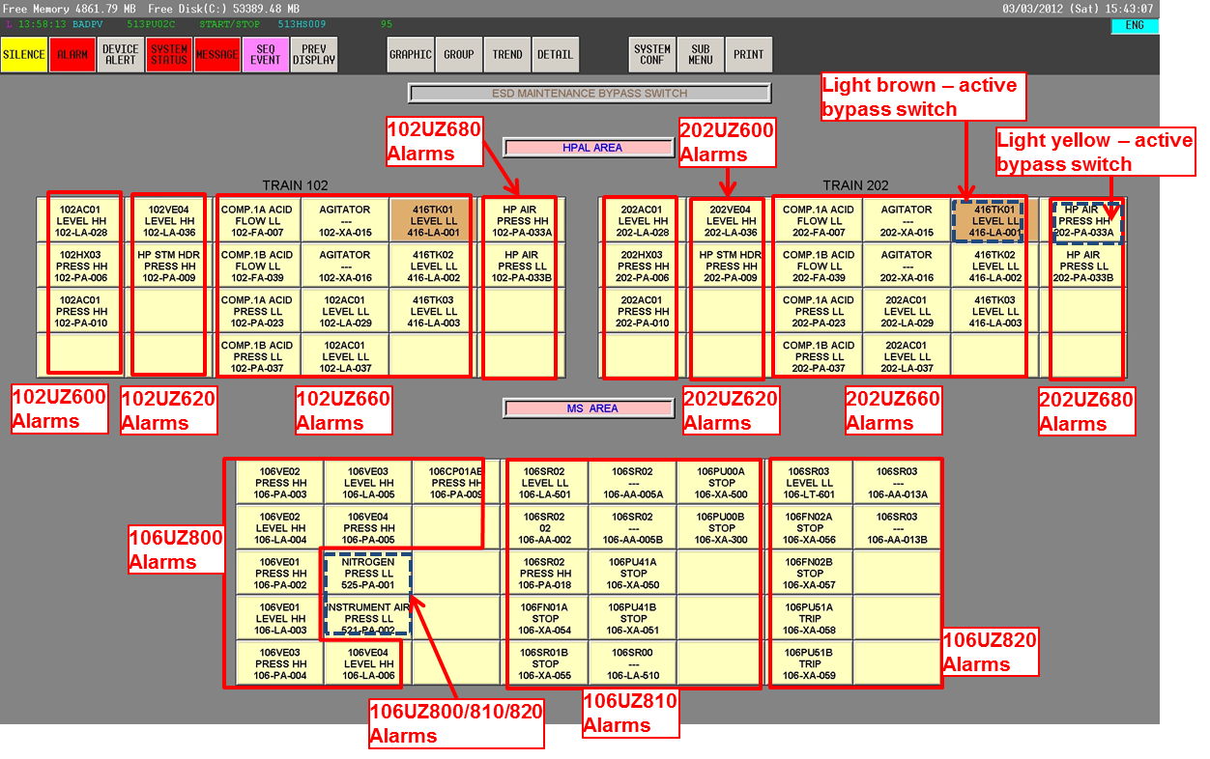

Annex 2: H2S MAINTENANCE BYPASS SWITCH DCS Graphics

